The Art of Scientific computation
A comparison of techniques for simulation of the abelian sandpile model

Summary

Introduction

Background

Sandpile Models
- Criticality
- Self-organized criticality
- Abelian sandpile model
- Generalised toppling processes
- Applications

Computational simulation
- Importance
- Challenges
- Programming languages
  - Python
  - Julia

Aims
- Impliment the Abelian Sandpile Model in Python and Julia
- Compare the performance of the two languages
  - Speed
  - Memory usage
  - Scalability
  - Numerical stability

Methodology

Simulation Algorithms

Toppling Algorithms

‘Push’ topple algorithm
The naive algorithm is naive in the sense that it is the most straightforward way to implement the toppling algorithm, but also in the sense that it does not assume any information about where topples might occur (i.e. it checks every site, c.f. the targeted algorithm). The algorithm iterates over each site in the lattice, and if the site has more sand than the threshold, it topples and sends sand to its neighbors.
#| label: alg-push_topple
#| html-indent-size: "1.2em"
#| html-comment-delimiter: "//"
#| html-line-number: true
#| html-line-number-punc: ":"
#| html-no-end: false
#| pdf-placement: "htb!"
#| pdf-line-number: true
\begin{algorithm}
\caption{Push toppling algorithm}
\begin{algorithmic}
\input{a $n \times m$ lattice $X$, topple threshold $k$, a site $i$}
\output{a $n \times m$ lattice $Y$}
\If {$X_{i} \geq k$}
\State $Y_{i} \gets X_{i} - k$
\For{each neighbor $j$ of $i$}
\State $Y_j \gets X_j + 1$
\EndFor
\Else
\State $Y_i \gets X_i$
\EndIf
\end{algorithmic}
\end{algorithm}
Because the every topple event using the naive algorithm effects the output of five locations on the lattice, the algorithm is not suitable for parallelization: the order of the for loop must be preserved to prevent multiple threads from updating the same site simultaneously (which would potentially lead to conflicting results when checking if a site is above the threshold). To remedy this limitation, we can use the parallel, or ‘pull’ algorithm

‘pull’ topple algorithm
The parrallel is based on the idea of “pulling” sand from neighbors rather than “pushing” sand to neighbors. Each cell is updated by checking each of it’s neighbours - for each neighbour that is ready to topple, the cell gains one grain. If the cell itself is ready to topple, it loses four grans. Each iteration of the for loop therefore only changes one site (i.e. each iteration is encapsulated), and therefore each cell can be updated in parallel.
#| label: alg-pull_topple
#| html-indent-size: "1.2em"
#| html-comment-delimiter: "//"
#| html-line-number: true
#| html-line-number-punc: ":"
#| html-no-end: false
#| pdf-placement: "htb!"
#| pdf-line-number: true
\begin{algorithm}
\caption{Pull toppling algorithm}
\begin{algorithmic}
\input{ a $n \times m$ lattice $X$, topple threshold $k$, a site $i$}
\output{a $n \times m$ lattice $Y$}
\If {$X_i \geq k$}
\State $Y_i$ $\gets$ $X_i - k$
\Else
\State $Y_i$ $\gets$ $X_i$
\EndIf
\For {each neighbor $j$ of $i$}
\If {$X_j \geq k$}
\State $Y_i$ $\gets$ $Y_i + 1$
\EndIf
\EndFor
\end{algorihmic}
\end{algorithm}

Stabilisation algorithms

Naive stabilisation algorithm
The naive stabilisation algorithm is naive in the sense that it is the most straightforward way to implement the toppling algorithm, but also in the sense that it does not assume any information about where topples might occur. It iterates over each site in the lattice, and if the site has more sand than the threshold, it topples. This loop is repeated until each cell is below the toppling threshold. This algorithm works effectively with both push and pull toppling algorithms.
#| label: alg-naive_stabilise
#| html-indent-size: "1.2em"
#| html-comment-delimiter: "//"
#| html-line-number: true
#| html-line-number-punc: ":"
#| html-no-end: false
#| pdf-placement: "htb!"
#| pdf-line-number: true
\begin{algorithm}
\caption{Naive stabilisation algorithm}
\begin{algorithmic}
\input{ a $n \times m$ lattice $X$, topple threshold $k$}
\output{ $n \times m$ lattice $Y$}
\While {any site in $X$ is above $k$}
\For {each site $i$ in $X$}
\If {$X_i \geq k$}
\State $Y$ $\gets$ topple!(X, i)
\Else
\State $Y_i$ $\gets$ $X_i$
\EndIf
\EndFor
\EndWhile
\end{algorihmic}
\end{algorithm}

Targeted stabilisation algorithm
This algorithm assumes we have information about the locations of potential topple sites. For example, when dropping a single grain of sand, we first can check if the drop site needs to toppled. If it doesn’t, there is no possibility of avalance and no other sites need to be checked. If it does, can topple that site and just check the the neighbors to which the sand spreads. While needing less checks, we now must keep track of the sites that need to be checked. It is expected that this algorithm will provide performance improvements when the number of sites that need to be checked is significantly less than the total number of sites (i.e. a ‘sparse’ avalance)
#| label: alg-targeted_topple
#| html-indent-size: "1.2em"
#| html-comment-delimiter: "//"
#| html-line-number: true
#| html-line-number-punc: ":"
#| html-no-end: false
#| pdf-placement: "htb!"
#| pdf-line-number: true
\begin{algorithm}
\caption{Targeted toppling algorithm}
\begin{algorithmic}
\input{ a $n \times m$ lattice $X$, topple threshold $k$, A list of sites to check $L$}
\output{ sandpile model lattice $Y$}
\While {$L$ is not empty}
\State remove element $i$ from $L$
\If {$X_i \leq k$}
\State $Y \gets$ topple!(X, i)
\EndIf
\EndWhile
\end{algorihmic}
\end{algorithm}

Implementation Details

Python Implementation
- naive
- parallel
- optimised
- total ### Julia Implementation
- naive
- parallel
- optimised
- total

Computational Environment
- Hardware
- Software
- Libraries ## Performance Metrics
- Execution time
- Memory consumption
- Scalability
- Numerical stability # Results

Performance Analysis

Different Toppling Algorithms
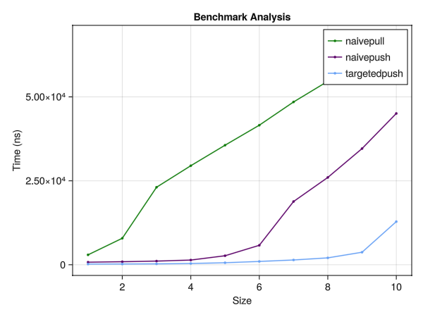
Execution time for different toppling algorithms

Properties of the Sandpile
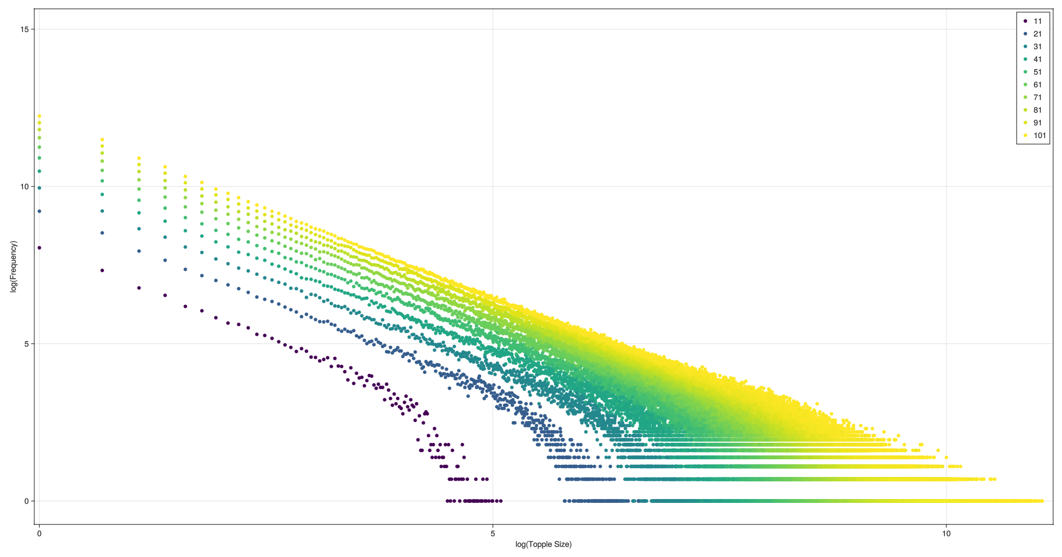
Distribution of avalanche sizes in the abelian sandpile model at different grid sizes
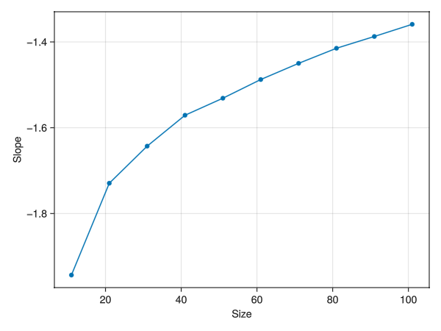
OLS coefficients for topple size and frequency bu lattice size

Comparison of Results

Discussion

Abelian model

Language comparison

Advantages and Limitations

Implications for Computational Simulations

Conclusion

Summary of Findings

Recommendations

Future Work

References

Appendices

